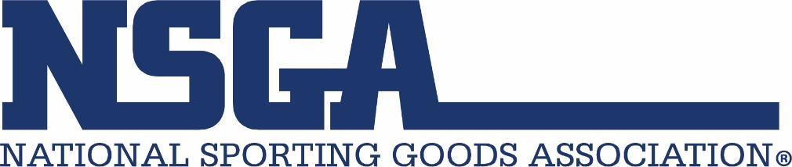

Forever Chemicals Known as PFAS Banned in Products Including Outdoor Apparel

What are PFAS?

Per- and Polyfluoroalkyl Substances (PFAS) are a group of synthetic chemicals that have been widely used in various industrial and consumer products to provide stain resistance, water repellency, and other properties intended to extend the life of the product and provide comfort to the user. Due to their lingering presence in the environment and potential health risks, there has been growing concern about PFAS safety.

Why do I need to know about PFAS?

Some states have passed regulations prohibiting the use and/or sale of apparel that contains PFAS including winter sports gear.

In New York, beginning January 1, 2025, no person can sell or offer for sale in New York any new, not previously used apparel containing intentionally added PFAS. In California, beginning January 1, 2025, no person can distribute, sell, or offer any new not previously owned textile articles that contain PFAS. Both California and New York laws require manufacturers to provide those persons that offer the products for sale or distribution in those states with a certificate of compliance stating that the textile article follows the provisions of the new regulations and does not contain any regulated PFAS. The California law has a threshold for “parts per million,” however, the threshold allows less PFAS in the coming years.

Maine has banned the sale of ski wax containing PFAS effective January 1, 2026, and also textiles with PFAS beginning January 1, 2026. Outdoor apparel for severe wet conditions containing intentionally added PFAS, can be sold until January 1, 2029, as long as the apparel is accompanied by a legible, easily discernable disclosure stating, "Made with PFAS chemicals."

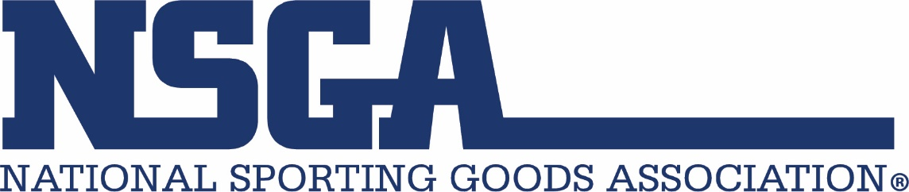

These bans on PFAS are not new. Effective July of 2023, Vermont banned PFAS in a number of products including ski wax and related tuning products. Many states have mandated the removal of PFAS from personal products, cookware, floor finishes, carpets, rugs, and certain furniture. Thirty-five other states are considering laws which ban the use of PFAS in a variety of products including outdoor apparel for children and adults.

What do I need to do about PFAS in my inventory and for future orders?

Retailers must educate themselves on state PFAS regulations and respond accordingly. In New York, fines for continued noncompliance are up to $2,500 per day. If your e-commerce sales include customers in New York, California, or any state likely to ban PFAS in the coming months, you must comply with the laws of those states.

Retailers should investigate whether their existing inventories contain PFAS and if these items can be sold after January 1, 2025. Conversations with suppliers about PFAS and obtaining certificates of compliance from manufacturers will help retailers avoid ordering new inventory that cannot be sold. Many suppliers have already taken measures to remove PFAS chemistry from their manufacturing processes. It is best to confirm which companies have discontinued the use of PFAS, which products may be impacted, and how this will affect your sales.

As some PFAS regulations include the removal of this chemistry from personal products, if you sell such products for sports enthusiasts, double check that they are PFAS compliant.
If your business does not sell to customers in states that are regulating PFAS in products you carry, be aware that suppliers may direct inventory with PFAS to your account. It is best to be cautious when receiving this merchandise as regulations could be enacted which affect you or you may receive inquiries from customers. Clear labeling on both the product and online will help to avoid uncertainty for both the retailer and the end-user.

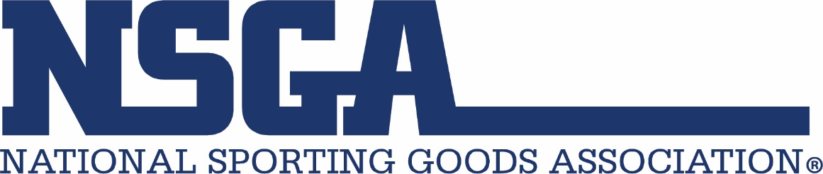

Where can I get more information?

Retailers are advised to consult with legal counsel about liability issues relating to products containing PFAS.

For information about California’s PFAS regulations PFAS Consumer Alert.pdf (ca.gov)

More information about Maine’s PFAS laws can be found at getPDF.asp (mainelegislature.org)

For information about New York’s PFAS regulations PFAS In Apparel Law - NYSDEC

